## Flashing the GPS Module UM980 for onocoy miner

* Connect your um980 with usb cable to your windows pc
* Copy the folder GPS MODUL on your pc
* Have a look in the device-manager, which com port have the um980  
  (if you don’t see the modul as usb serial ch340, you have to install the driver ( I put it in the esp32 folder)  
    
  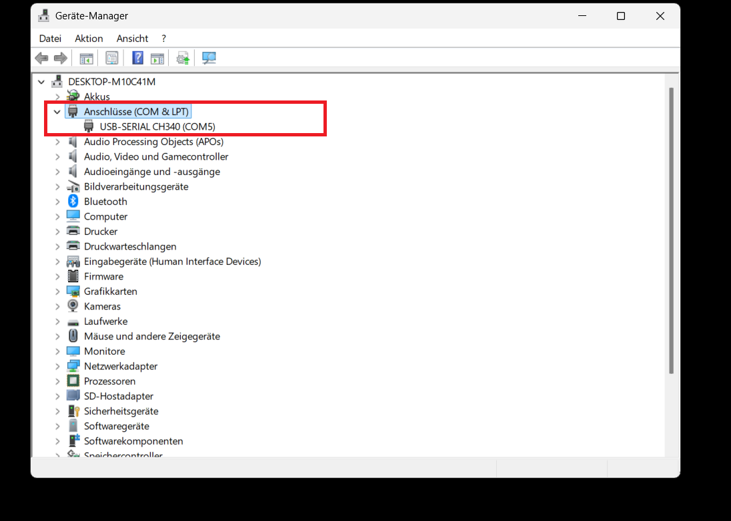
* Open a terminal, easiest way is right click the gps module folder and “open terminal”  
  (on the picture as “Im Terminal öffnen”

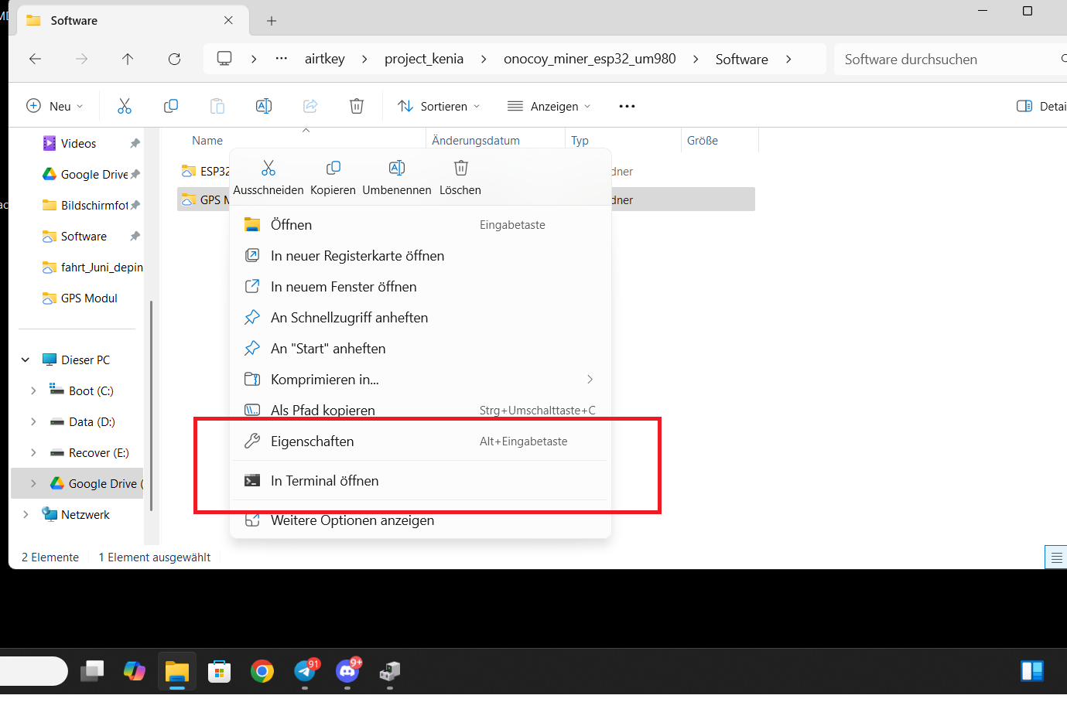

* Start flashing with:  
  (if you have com port 4, chance COM5 to COM4)  
  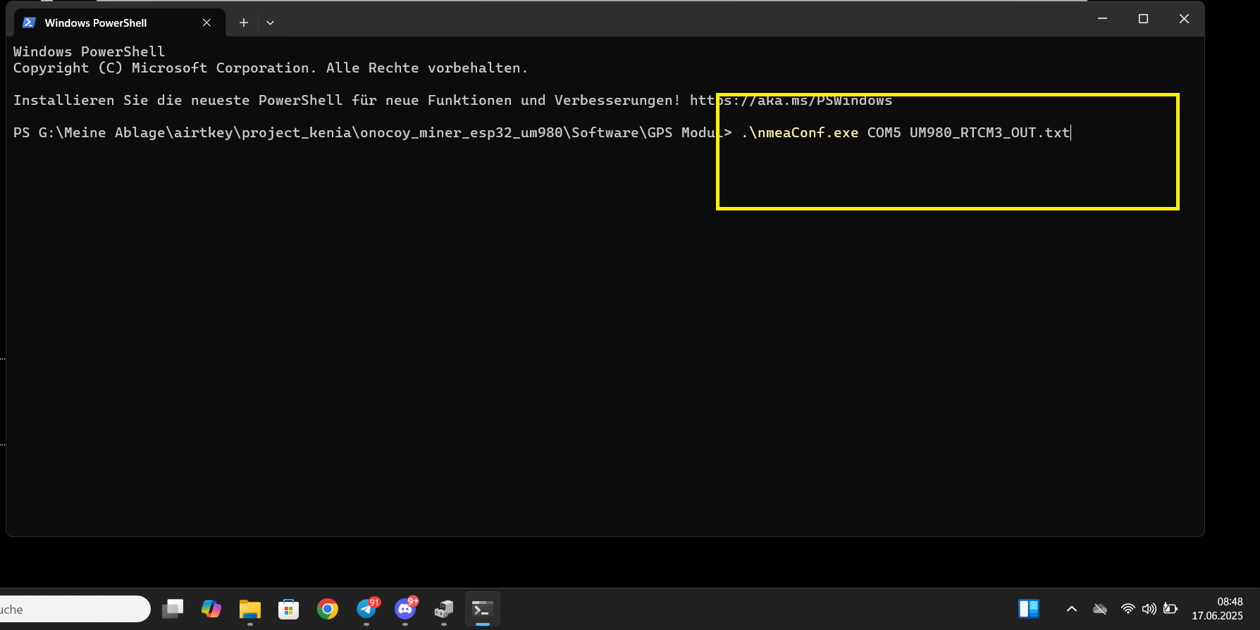

- flashing is done and ok:

